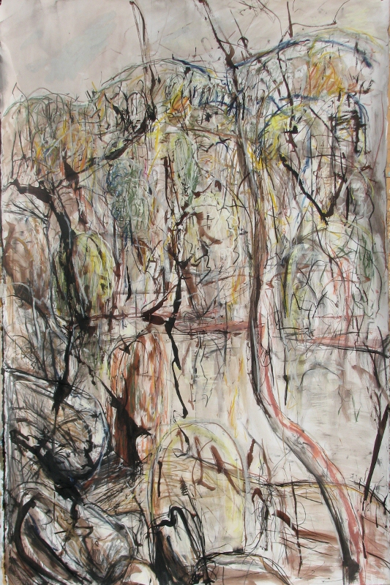

ipod, iphone, ipad Photo Competition

Registration Form

Participants Name: ________________________________________________________________

E-Mail address: ________________________________________________________________

Mailing address: ________________________________________________________________________________________________________________________________

Phone:

________________________________________________________________

Number of photos being entered: _____________________

Amount Paid: ______________

Parental permission if under the age of 18 years

________________________________________________________________